Package.json:
{
"name": "demo-node-app",
"version": "1.0.0",
"main": "index.js",
"scripts": {
"watch": "nodemon ./start.js"
},
"keywords": [],
"author": "",
"license": "ISC",
"description": "",
"dependencies": {
"body-parser": "^1.20.3",
"dotenv": "^16.4.5",
"express": "^4.21.1",
"express-validator": "^7.2.0",
"http-auth": "^4.2.0",
"mongoose": "^8.8.1",
"pug": "^3.0.3"
},
"devDependencies": {
"nodemon": "^3.1.7"
}
}

Package-lock.json
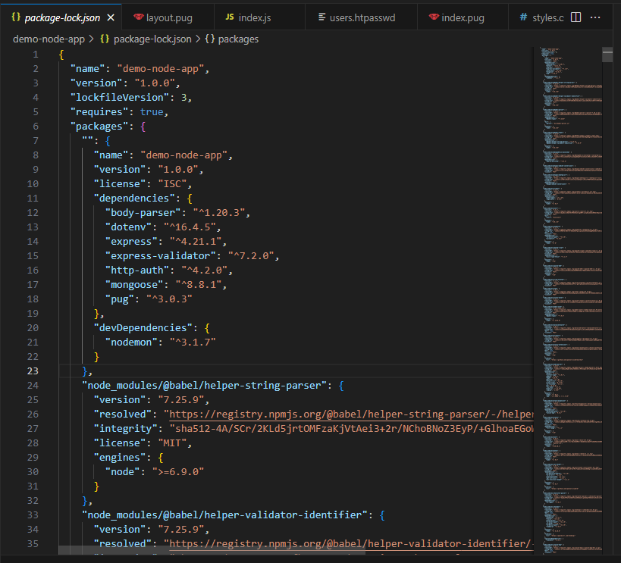

Start.js
require('dotenv').config();
const mongoose = require('mongoose');
require('./models/Registration');

mongoose.connect(process.env.DATABASE, {
useNewUrlParser: true,
useUnifiedTopology: true
});

mongoose.connection
.on('open', () => {
console.log('Mongoose connection open');
})
.on('error', (err) => {
console.log(`Connection error: ${err.message}`);
});

const app = require('./app');
const server = app.listen(3000, () => {
console.log(`Express is running on port ${server.address().port}`);
});

Index.js
const express = require('express');
const mongoose = require('mongoose');
const path = require('path');
const auth = require('http-auth');
const Registration = mongoose.model('Registration');
const router = express.Router();
const basic = auth.basic({
file: path.join(__dirname, '../users.htpasswd'),
});
const { check, validationResult } = require('express-validator');
router.get('/', (req, res) => {
res.render('form', { title: 'Registration form' });
});

//router.post('/', (req, res) => {
//console.log(req.body);
//res.render('form', { title: 'Registration form' });

//});
router.post('/',
[
check('name')
.isLength({ min: 1 })
.withMessage('Please enter a name'),
check('email')
.isLength({ min: 1 })
.withMessage('Please enter an email'),
],
(req, res) => {
const errors = validationResult(req);

if (errors.isEmpty()) {
const registration = new Registration(req.body);
registration.save()
.then(() => { res.send('Thank you for your registration!'); })
.catch((err) => {
console.log(err);
res.send('Sorry! Something went wrong.');
});
} else {
res.render('form', {
title: 'Registration form',
errors: errors.array(),
data: req.body,
});
}
}
);

router.get('/registrations', basic.check((req, res) => {
Registration.find()
.then((registrations) => {
res.render('index', { title: 'Listing registrations', registrations });
})
.catch(() => { res.send('Sorry! Something went wrong.'); });
}));
module.exports = router;

Registration.js
const mongoose = require('mongoose');

const registrationSchema = new mongoose.Schema({
name: {
type: String,
trim: true,
},
email: {
type: String,
trim: true,
},
});

module.exports = mongoose.model('Registration', registrationSchema);

form.pug
extends layout

block content
-data = data || {}

div.form-wrapper
if errors
ul.error-messages
for error in errors
li= error.msg

form(action="." method="POST")
div.mb-3
label(for="name" class="form-label") Name:
input(
type="text"
class="form-control"
id="name"
name="name"
placeholder="Enter your name"
value=data.name
)
div.mb-3
label(for="email" class="form-label") Email:
input(
type="email"
class="form-control"
id="email"
name="email"
placeholder="Enter your email"
value=data.email
)

input(
type="submit"
class="btn btn-primary"
value="Submit"
)

Index.pug
extends layout

block content

if registrations.length
table.table.table-bordered.table-striped.mt-5
thead.table-dark
tr
th Name
th Email
tbody
each registration in registrations
tr
td= registration.name
td= registration.email
else
p No registrations yet :(

layout.pug
doctype html
html
head
title= `${title}`
link(rel='stylesheet', href='/css/bootstrap.min.css')
link(rel='stylesheet', href='/css/styles.css')

body
div.container
h1.text-center.mb-4 Event Registration

block content

app.js
const express = require('express');
const path = require('path');
const routes = require('./routes/index');
const bodyParser = require('body-parser');
const app = express();
app.use(express.static('public'));
app.set('views', path.join(__dirname, 'views'));
app.set('view engine', 'pug');

app.use(bodyParser.urlencoded({ extended: true }));
app.use('/', routes);

module.exports = app;

